SCIENCE TALK – SPECIAL ISSUE

Farewell Letter from Nicholas Maxwell

September 2024
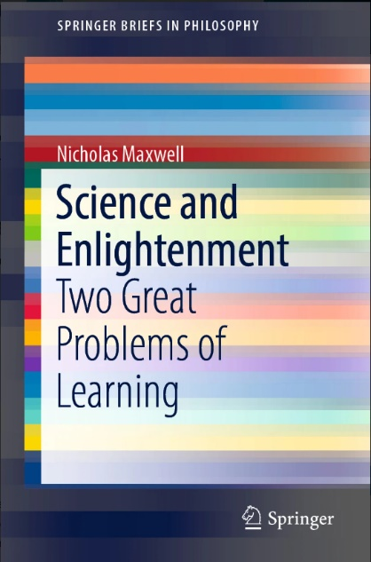
I have just been told by my doctor that I have only a few weeks left to live. (I have myeloma, and the treatment I am on, the last available, shows signs of giving up.) I thought I would use the occasion to get in touch with friends and colleagues to make one last attempt at trying to get across, once more, just how urgent the message is that I have been trying to communicate for the last 50 years or so, and what a disaster it is that this message should just be ignored as, basically, it has been so far.
We might put the matter like this. Humanity faces two absolutely fundamental problems of learning: learning about the universe and ourselves and other forms of life as a part of the universe; and learning how to create a genuinely good, civilized, wise world. We have solved the first problem of learning. We did that in the 17th century when we created modern science. But we have not yet solved the second problem.^{[i]} This puts us in a situation of unprecedented danger. For, as a result of solving the first problem and creating modern science and technology, we have enormously increased our power to act. We have employed this vastly increased power to act to enhance human welfare in endlessly many ways, via the development of modern medicine and hygiene, modern industry and agriculture, modern transport and communications, and in countless other ways. But, in the absence of the solution to the second great problem of learning, these very successes, the outcome of our enhanced power to act have, as often as not, also led to harm and death. They have led to population growth, environmental degradation, loss of wild life, mass extinction of species, gross inequality, the lethal character of modern war, the threat of nuclear weapons, pollution of earth, sea and air, and above all to the impending disasters of climate change. All these global problems come from a single source: our immense success in solving the first great problem of learning and our lamentable failure to solve the second great problem of learning.
It is this deadly combination of science without civilization that is at the root of many of our most threatening global problems. Before science, lack of wisdom did not matter too much. We lacked the power to do too much damage to ourselves, or to the planet. Now that we do have science, and the power to act that it bequeaths to us – to some of us at least – lack of global wisdom has become a menace. Wisdom has ceased to be a private luxury and has become a public necessity. Solving the first great problem of learning and failing to solve the second one puts us into a situation of extreme and unprecedented danger. As a matter of extreme urgency – now we have solved the first great problem of learning – we must discover how to solve the second one. If we do not learn soon how to make progress towards a wiser, more civilized world, we may well end up destroying ourselves.
But how is this to be done? Prophets and philosophers have been holding forth on the need for wisdom for millennia, without much apparent success. The very idea that humanity can make social progress towards a better, wiser world has become thoroughly dubious in recent times, even disreputable.
Here is the key to the solution of this crisis. We need to learn from our solution to the first great problem of learning how to go about solving the second great problem. As a result, we might get into efforts to achieve social progress towards a good world some of the incredible success of science in achieving intellectual progress in knowledge.
This is not an entirely new idea. It goes back to the 18th century Enlightenment. A key idea of the Enlightenment, especially the French Enlightenment, was to learn from scientific progress how to make social progress towards an enlightened world. (Peter Gay’s The Enlightenment is still, in my view, the best overall account of The Enlightenment.)
In order to put this Enlightenment idea into practice properly, so that we really do learn from scientific progress how to achieve social progress towards a good, enlightened world, there are three crucial steps that must be got right. First, we must capture correctly the progress-achieving methods of science – that which makes scientific progress possible. Second, we must generalize these progress-achieving methods of science correctly, so that they become applicable in a potentially fruitful way to all worthwhile, problematic human endeavours. Third, we need to get into personal, institutional and social life these progress-achieving methods arrived at by generalizing the methods of science – so that we can get into our efforts to achieve what is of value in life some of the success and progress achieved by science.
Put these three steps correctly into practice, and we would have what humanity so urgently needs: a kind of inquiry devoted to helping humanity make progress towards a civilized, enlightened, wise world.
Unfortunately, the philosophes of the 18th century French Enlightenment, Voltaire, Diderot, Condorcet and the rest, in developing and implementing this profoundly important idea of learning from scientific progress how to achieve social progress towards an enlightened world, made dreadful blunders. They got all three steps drastically wrong. First, they failed to capture correctly the progress-achieving methods of science. Second, they then failed to generalize scientific method correctly so as to facilitate progress in other fields of human endeavour besides science. Third, and most disastrously, they failed to apply progress-achieving methods, generalized from science, to the social world, and above all to the task of making progress towards an enlightened world. Not only did they fail to formulate correctly progress-achieving methods, generalized from those of natural science, fruitfully applicable potentially to all worthwhile, problematic human endeavours. Far worse, they did not even conceive of the task in this methodological way. Instead, they thought the task was to develop the social sciences alongside the natural sciences. Thus the philosophes set about creating and developing the social sciences: economics, psychology, sociology, anthropology, and the rest. Instead of attempting to apply reason, extracted from science, to the task of making progress towards an enlightened world, the philosophes sought merely to make progress in knowledge about the social world. They thought that such knowledge had to be acquired as an essential preliminary to the task of making social progress towards enlightenment and civilization.
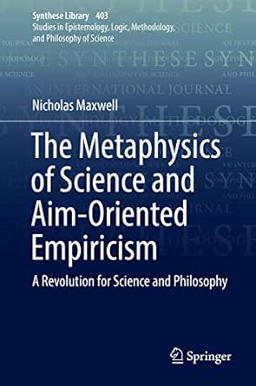
This botched version of the profound, basic Enlightenment idea was developed throughout the 19th century by J.S. Mill, Karl Marx, Max Weber, Emile Durkheim and others, and was then built into academia in the early 20th century with the creation of academic social sciences: economics, anthropology, psychology, sociology and the rest. As a result, modern science, and modern academic inquiry more generally, still embody the three ancient blunders of the 18th century Enlightenment. Academic inquiry as it exists today is the outcome of an attempt to put the profound, basic Enlightenment idea into practice – the idea of learning from our solution to the first great problem of learning how to solve the second one. Unfortunately it is a very seriously botched attempt. As a consequence, academia today does not, as it should, actively seek to help humanity solve those problems of living, including global problems, that need to be solved if humanity is to make progress towards a better, wiser, more civilized and enlightened world. Instead, it devotes itself to acquiring and applying knowledge – knowledge of the natural world, and knowledge of the social world. Judged from the standpoint of helping humanity learn how to create a better world, academic inquiry, devoted primarily to the pursuit of knowledge, is damagingly irrational in a wholesale, structural way, and this irrationality of our institutions of learning has much to do with the dangerous situation we find ourselves in today. We fail to learn how to make progress towards a better world because our institutions of learning are profoundly dysfunctional intellectually. They have in them three structural blunders inherited from the Enlightenment. In devoting themselves primarily to the acquisition and application of knowledge, universities in the modern era have in effect restricted themselves to putting the solution to the first great problem of learning into practice, to the neglect of the second problem, and in doing so they have intensified the danger we are in that comes from enhanced power to act bequeathed to us by the success of science without the global civilization required to use this power wisely.
In order to develop universities that are actively, rationally, and perhaps effectively engaged in helping us create a more civilized world, it is essential that we cure academia of its three big defects inherited from The Enlightenment. First, we need to adopt and implement a new conception of science that acknowledges profoundly problematic metaphysical, value and political assumptions inherent in the aims of science and, as a result, adopts a meta-methodology designed to facilitate improvement of aims and associated methods as science proceeds. Second, this aims-improving, progress-achieving conception of scientific method needs to be generalized to form a new, aims-improving, progress-achieving conception of rationality, fruitfully applicable, potentially, to all worthwhile endeavours with problematic aims. And third, social inquiry and the humanities need to be transformed so that they take up the task of helping humanity get this new conception of rationality into the fabric of social life, into all our other human endeavours besides science: politics, industry, agriculture, economics, the media, the law, finance, international affairs. It is essential that universities, and the more general social and political effort to make progress towards civilization, put into practice the aims-and-methods improving conception of rationality arrived at by generalizing and adapting the aims-and-methods methodology of science, because civilization, like the basic aims of science, is inherently and profoundly problematic. Ideas about what a civilized world might be, desirable and attainable, will need to be improved as we proceed. As a result of putting these three key steps into practice, correcting the three blunders we have inherited from The Enlightenment, humanity would have what it so urgently needs, a kind of academic enterprise rationally devoted to helping us make social progress towards a genuinely civilized, wise, enlightened world – a world that has the capacity to discover undesirable consequences of new actions made possible by new technology, and then modify actions before their undesirable consequences become too widespread. Furthermore science, transformed as a result of implementing the aims-and-methods improving methodology that corrects the first blunder inherited from the past, would be better, potentially, at improving our scientific knowledge and understanding of the universe, and would be better able to respond to the most urgent and best interests of humanity.
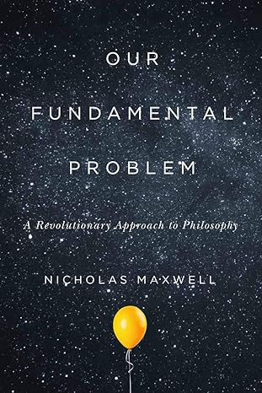
Here, then, in very brief outline, is an argument that, if valid, establishes the urgent need to bring about a profound intellectual and institutional revolution in universities around the world so that universities may cease to play a role in intensifying global problems that threaten our future, and may instead, come actively to help us resolve these global problems and thus begin to make social progress towards a genuinely civilized world. Even if we lived in peaceful, civilized times, I would have thought this argument deserved to receive serious attention. In our world, fraught with war, dictatorial regimes, poverty, democracy under threat, the menace of the climate and nature crises, and with nuclear weapons at the ready in the wings, I would have thought that an argument that claims to show that universities have some responsibility for this situation, and how they need to change to become more helpful, ought to receive more attention than the neglect my argument has actually received.
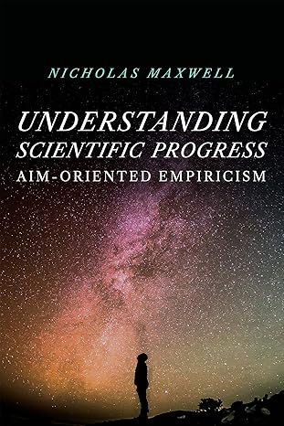
Why has it been ignored? Perhaps the very immense scope of the argument tells against it. It does not fit into the modern specialized academic mind. Perhaps it is the lack of success of the argument that tells against it. Just as nothing succeeds like success, perhaps nothing fails like failure. Perhaps individual academics are discouraged from taking the idea seriously because of the apparent impossibility of it ever being taken up and put into academic practice. To that objection I do have a reply. It is first of all perfectly possible to create serious academic discussion of the argument – discussion of potential objections, discussion of how aspects of the idea might be put into practice, what practical objections and difficulties there might be. Furthermore, the basic idea that knowledge-inquiry needs to be transformed into wisdom-inquiry (as I call the two kinds of academic inquiry at issue) does not, of course need to be done in one blow, all at once. Bits and pieces of knowledge-inquiry can be modified to become bits of wisdom-inquiry. Not all the social sciences need to be transformed in one revolutionary act, and nor do all the natural sciences either. Some components of the changes that are needed are much easier to change than other components. I have drawn up a list of 23 structural changes that are needed to transform knowledge-inquiry into wisdom-inquiry. Some involve changes in disciplines; those are hard to change, because they involve changing aspects of universities all around the world. But other changes do not involve changes in disciplines, and those can be made, university by university, each acting independently. That applies to the idea that there should be sustained imaginative and critical exploration in the university of our fundamental problem: How can our human world exist and best flourish embedded as it is in the physical universe? See What Needs to Change Step 20. It applies to steps 22 and 23 as well. Elements of wisdom-inquiry could be created, in this or that university, and that might well form growth points for more substantial change in the future. The matter is too urgent to leave for another generation to deal with, or likewise ignore.
There are of course any number of reasonably obvious intellectual and institutional reasons why what I advocate should be resisted. But the argument has not even reached that stage yet. Most academics, even most philosophers, have not even heard of it.
Some academics are actively concerned to change academia so that it comes to respond more adequately to the problems we face: see Faculty for a Future for example. I have tried to interest them in my work. They have seemed not that interested, and it is not reflected in their activities in any way.
That is the tragedy, I suppose, that I face as I head towards death. All the work I have put in has turned out to be wasted because it never became sufficiently known when no one was taking such matters seriously, and now that they are, my work is ignored as an ancient irrelevance from the past. So there we are. I have to accept that much of my working life – much of my life – has been a wasted effort.
Sorry to end on this rather mournful note. All best wishes to you,
– Nick

Incidentally, the argument I have just outlined very briefly first appeared in a book published in 1976, called What’s Wrong With Science?, written in three weeks to meet the publisher’s deadline. Most of the book takes the form of a furious debate between a Scientist and a ‘Philosopher’ about the issues. My next book, From Knowledge to Wisdom, published in 1984, spells out the argument with great care and in some detail. It took 5 years to write. 14 subsequent books develop diverse aspects of the basic argument for the urgent need for the academic revolution. One of these, Karl Popper, Science and Enlightenment, a collection of articles, is available free online like the two already mentioned. For a lively account of my 50 year struggle to get a hearing for the argument for the urgent need for the academic revolution see How Universities Have Betrayed Reason and Humanity—And What's to Be Done About It. Over the decades, I have published a number of articles, all available free online, that summarize in diverse ways the basic argument indicated above; see, for example, What kind of inquiry can best help us create a good world?, 1992; The Urgent Need For An Academic Revolution: The Rational Pursuit Of Wisdom, 2010; Can Universities Save Us From Disaster?, 2017; How Wisdom Can Help Solve Global Problems.2019; or The Scandal of the Irrationality of Academia, 2019.

